### SSN COLLEGE OF ENGINEERING

**Department of Computer Science and Engineering CS6712 Grid and Cloud Computing Laboratory**

##### Assignment -11 : Mounting Hadoop using FUSE

**Assigned Date: 08.09.2018. Due Date: 08. 09.2018 & 08 .09.2018**

* + 1. Hadoop Single node installation
    2. Hadoop Fuse Installation
    3. Hadoop Fuse Configuration
    4. Mounting HDFS
    5. HDFS mount using FUSE
    6. Display the file system details
    7. Unmount HDFS
    8. Display the file system details

Follow the below link.

<http://solutionsatexperts.com/hadoop-fuse-installation-and-configuration-on-centos/>

**MOUNTING HADOOP USING FUSE**

###### AIM:

EX NO 11

To install hadoop fuse and mount and unmount HDFS using fuse.

###### PRE-REQUISITES:

Single Node Hadoop installation (Refer Ex 10)

###### PROCEDURE:

* + - 1. **$ wget**

[**http://archive.cloudera.com/cdh5/one-click-install/trusty/amd64/cdh5-**](http://archive.cloudera.com/cdh5/one-click-install/trusty/amd64/cdh5-repository_1.0_all.deb)[**repository_1.0_all.deb**](http://archive.cloudera.com/cdh5/one-click-install/trusty/amd64/cdh5-repository_1.0_all.deb)

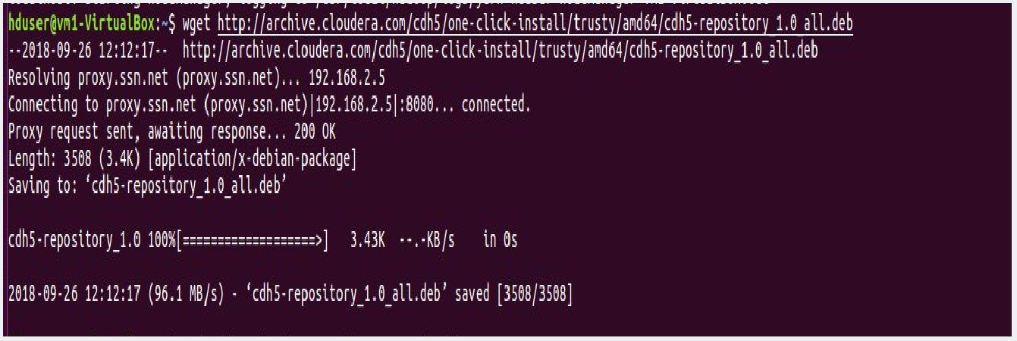

* + - 1. **$ sudo dpkg -i cdh5-repository_1.0_all.deb**

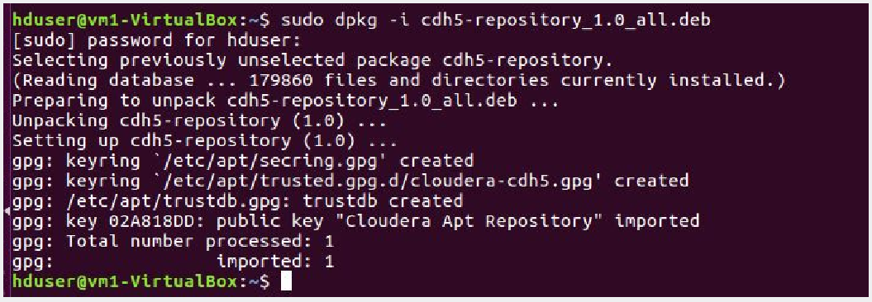

* + - 1. **$ sudo apt-get update**

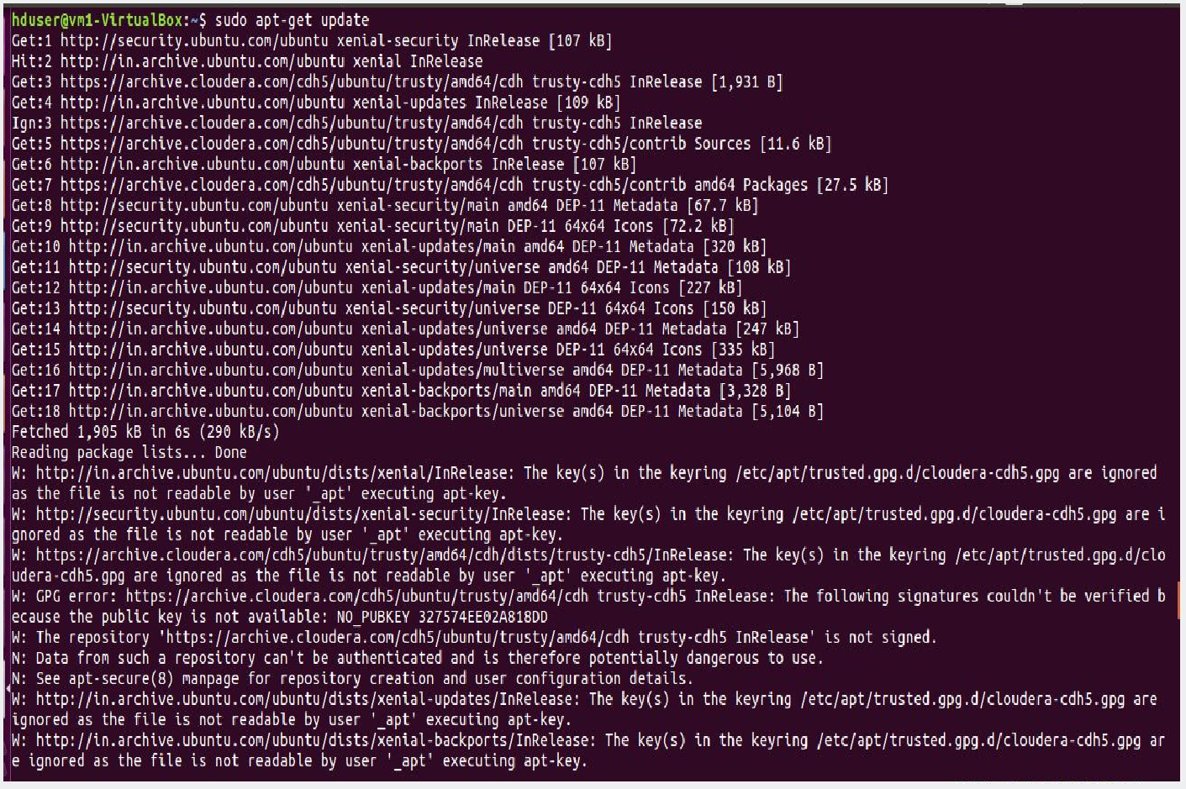

* + - 1. sudo apt-get install hadoop-hdfs-fuse

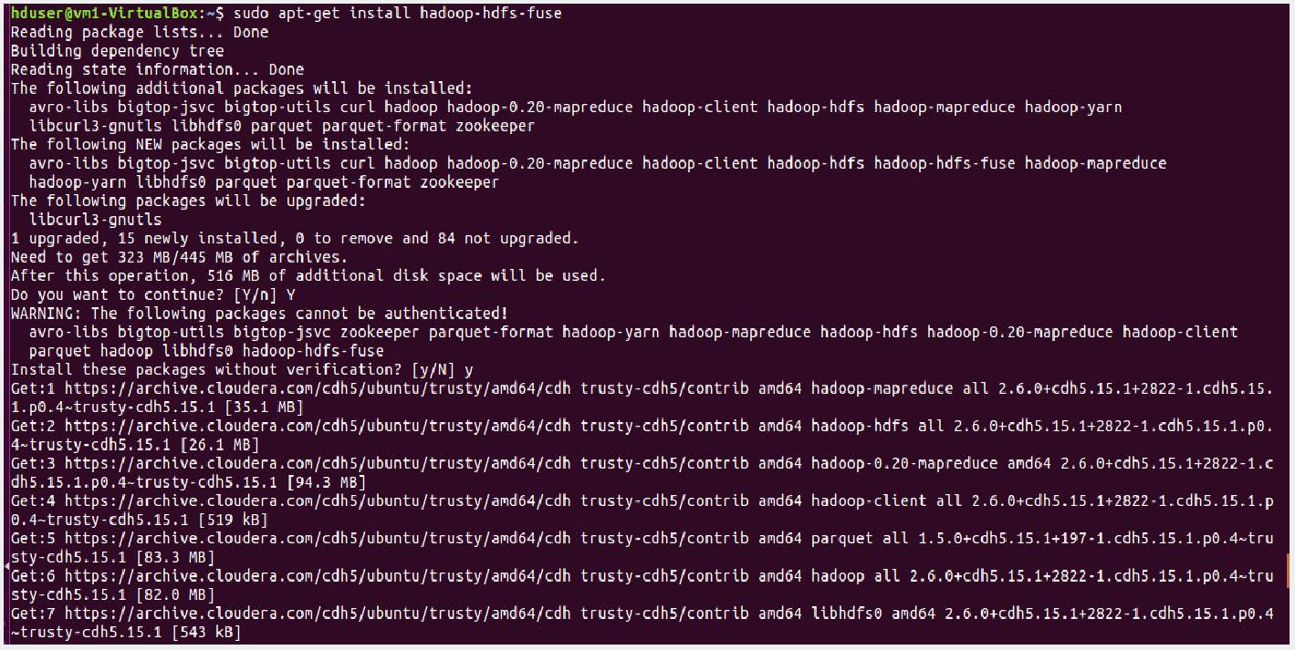

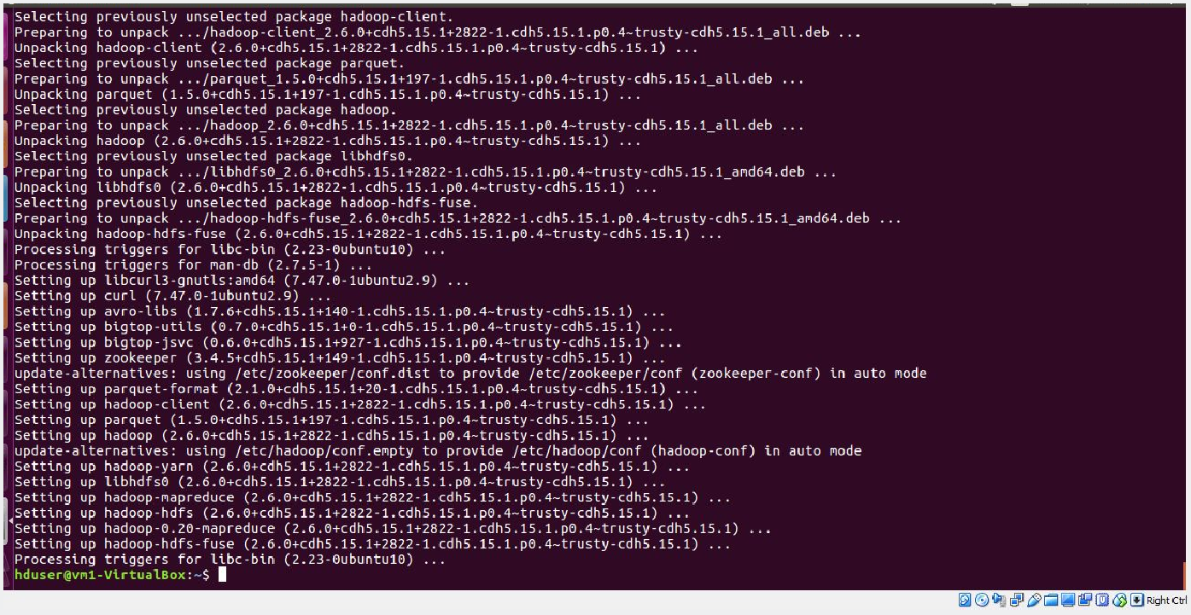

* + - 1. **$ sudo mkdir -p <mount_point>**
      2. **$ hadoop-fuse-dfs dfs://<name_node_hostname>:<namenode_port>**

**<mount_point>**



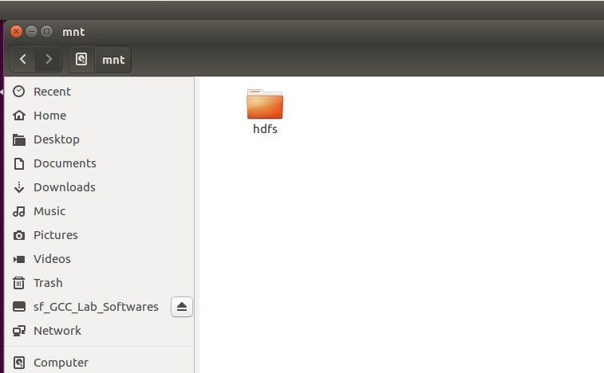

###### RESULT :

Thus, hadoop fuse is installed and hdfs is mounted and unmounted from the local file system using fuse.